<http://aprendehaskell.es/main.html>

solución fácil

s x y=x+y

r x y=x-y

m x y=x\*y

d x y=x/y

Ejecución

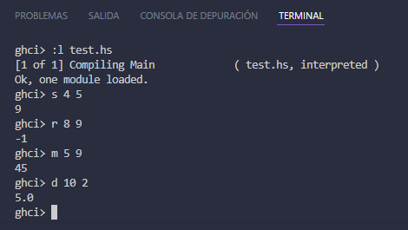

Solución difícil

import Data.List

solveRPN :: (Num a, Read a) => String -> a

solveRPN = head . foldl foldingFunction [] . words

    where   foldingFunction (x:y:ys) "\*" = (x \* y):ys

            foldingFunction (x:y:ys) "+" = (x + y):ys

            foldingFunction (x:y:ys) "-" = (y - x):ys

            foldingFunction xs numberString = read numberString:xs

Ejecucion

